35. Ecosystems *(Chapter 54)*

______________________________________________________________________________

I. Productivity of Ecosystems *(1283-1289)*

A. Energy Input

B. Primary Productivity

1. Definition

-Only 2% of the energy from the sun is used

C. Gross *versus* Net Primary Productivity

-amount of new plant matter created

-Maintenance cost – respiration 50% of energy used by plant

-Net Primary Productivity = Gross Primary Productivity - Respiration

1. Respiration and net primary productivity

2. Units of measure

-kCal or joules/cm^2/year

-Biomass = dry weight

3. Example from nature

-Warm wet terrestrial environments have most productivity

-Farmers use irrigation and fertilization

-Some productivity is lost to animal competition

-Use pesticide and herbicide

-Temporarily increase productivity

-Cannot each much of the biomass of corn

D. Limits to Productivity on Land

1. Water as a limiting resource

2. Examples from natural systems

3. Goals of agriculture

E. Limits to Productivity in the Sea

-Established by phytoplankton (drift with currents)

-Availability of light and nutrients available in the sea

-Light cannot penetrate below 120 meters (sometimes shorter)

-Nutrients in the sea often come from dead and decomposing organisms

-Nutrients fall bottom from dead organism

-Light and nutrients in different places

-Productivity in the seas is lower as a result

1. Vertical zonation

-Upwelling – vertical current

-Brings nutrients to the top of the ocean (4x more productive)

-Fishing on continental shelfs (higher productivity)

2. Light and nutrients as limiting resources

3. Upwelling and the mixing of seawater

II. Energy Flow and Ecological Efficiency *(1289-1295)*

A. Limits to Net Productivity

B. Consumers and the Multiplicative Loss of Energy

1. Limits to herbivore productivity

-productivity of a tropic level = amount of new tissue produce per unit are/time

2. Maintenance costs of animals: respiration

3. Paths of energy loss

-Animals – maintenance cost (respiration) – usually on the order of 80-95% (more for endotherms)

-About 10% of the energy consumed goes into herbivore or carnivore productivity

-Most energy does not transfer

4. Ecological efficiency and the multiplicative loss of energy

-Ratio of productivity of a tropic level/productivity of the level below it

-Productivity herbivore – productivity of herbivore/productivity of plant = 10%

C. Ecological Pyramids: Productivity, Biomass, and Numbers

Tropic Level EE Biomass

-Plants 100g

-Insect 10% 10g

-Lizard 15% 1.5g

-Hawk 10% 0.15g

III. Nutrient Cycling *(1295-1300)*

-Energy leaks out of every transfer (inefficient)

A. Review of Energy Flow

B. General Patterns of Nutrient Cycling

-No ongoing cosmic input, everything is here

-Closed System

-Biogeochemical cycle

-Accumulate in pools i.e. O_2 in the atmosphere

-Processes that move from unavailable to available are slow

1. Sources of nutrients

2. The biosphere

3. Atmospheric and sedimentary cycles

C. A General Compartment Model of Nutrient Cycles

1. Available compartments and unavailable compartments

2. Movement among the available compartments

3. Movement between available and unavailable compartments

D. Principles of Nutrient Cycling

1. Nutrients vary in form

-0_2 is water/rocks/atmosphere

2. Cycling follows paths of energy flow

-When nutrients are in living organisms they work their way through a food web

3. Higher trophic levels depend on lower trophic levels

4. Complexity and integration of biogeochemical cycles

-Interconnected largely because of water

5. Steady states in undisturbed systems

6. Worldwide nutrient cycles as a closed system

35-1

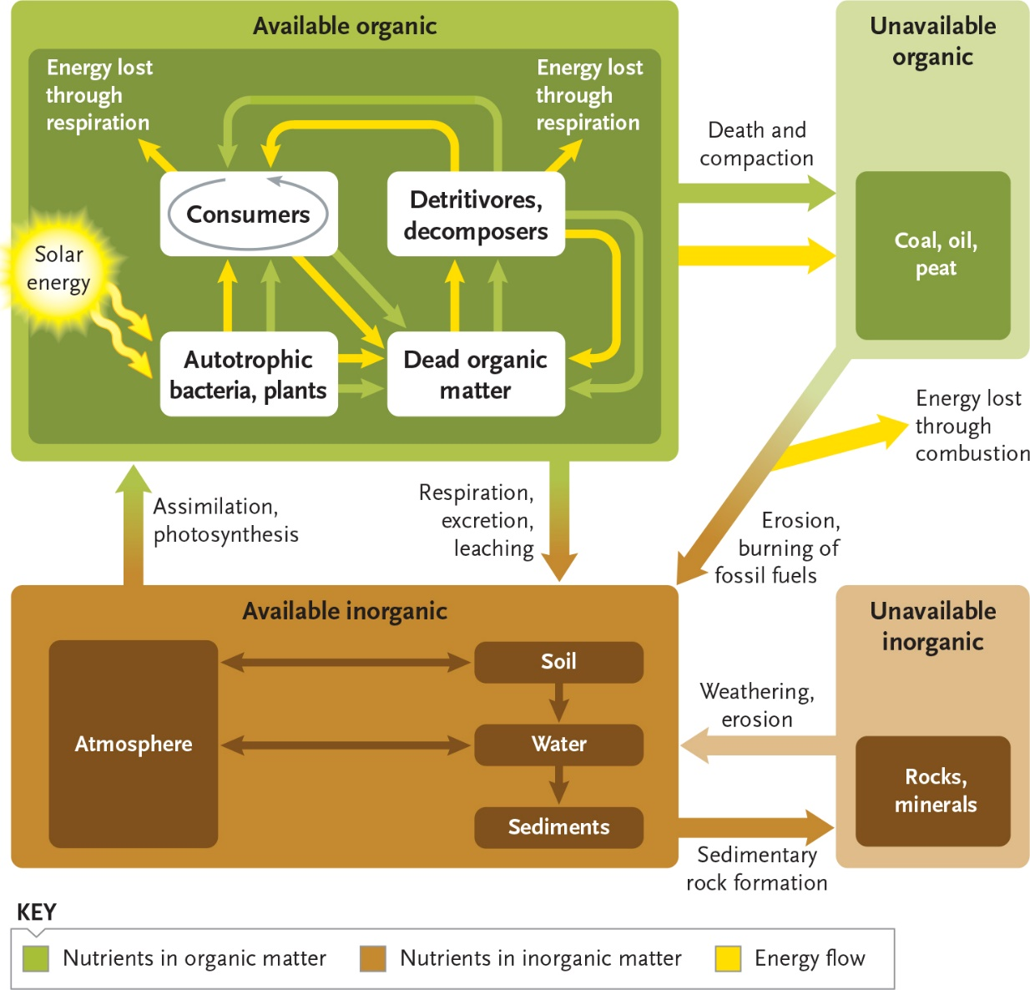

35-2

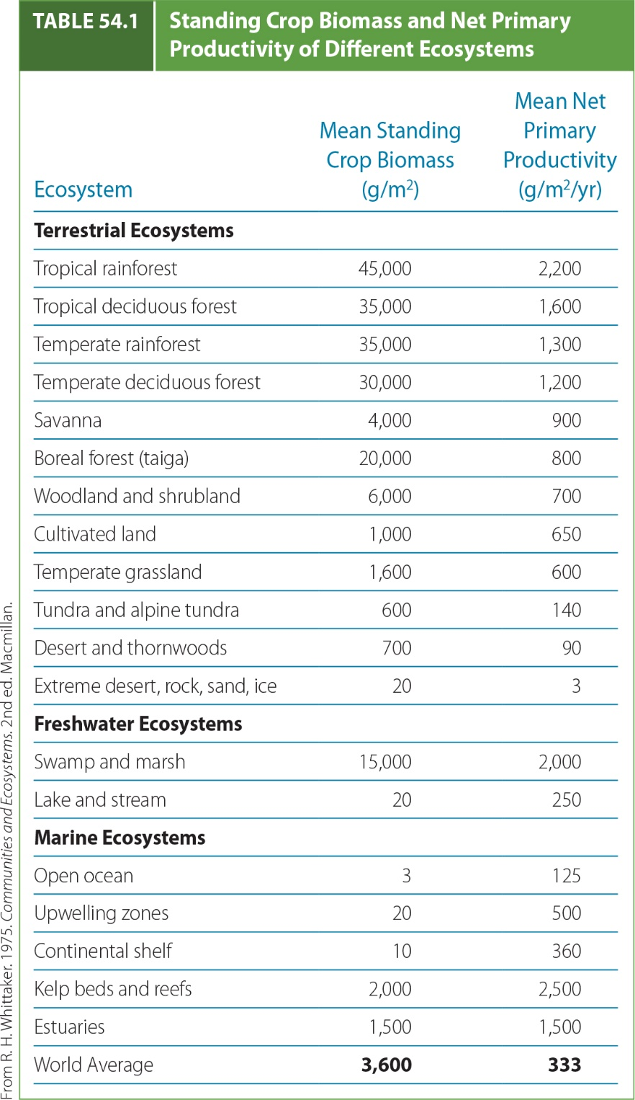

35-3

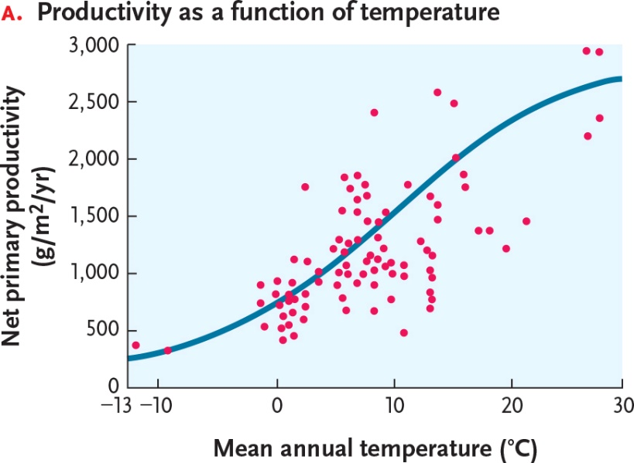

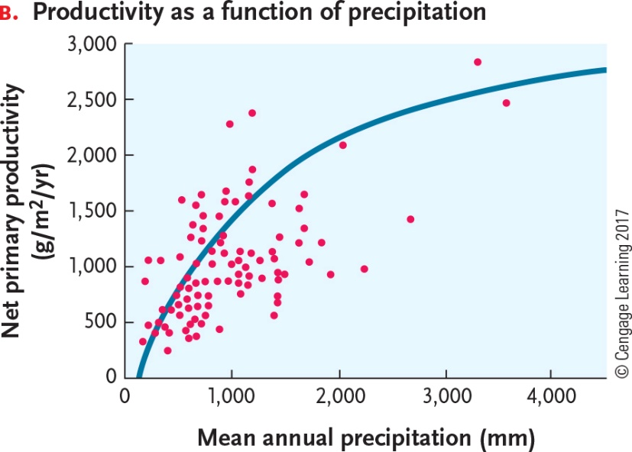

35-4

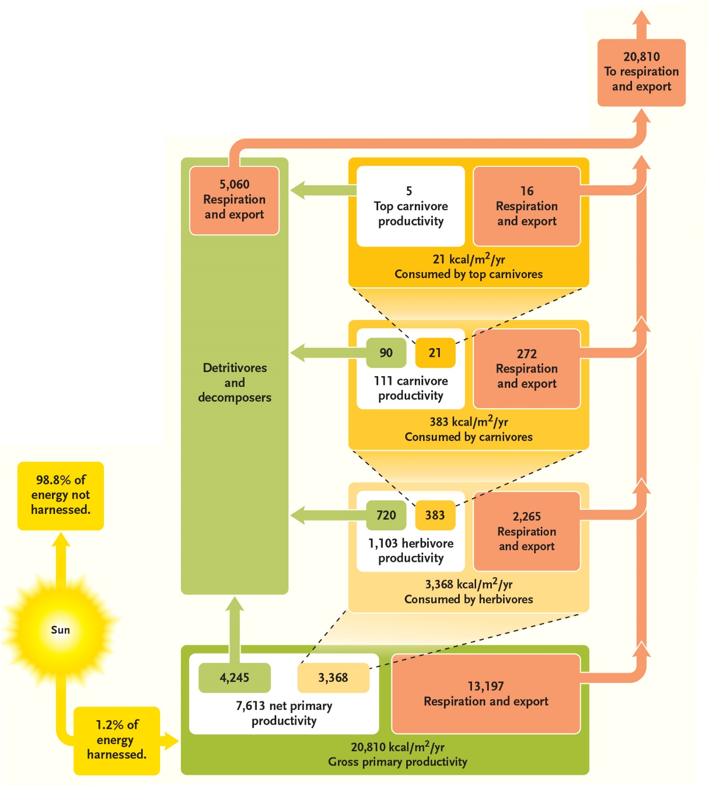

x

35-5

